Software Requirement Specification Document

For

Online Examination System

Table of Contents
Page Numbers
- Introduction 3
  - Purpose 3
  - Intended Customers/Users 3
  - Product Scope 3
  - Outline of the document 3
- Overall Description 4
  - Product Perspective 4
  - Product Functions 4
  - User Classes 4
  - Design and Implementation Constraints 4
- Diagrams 5-29
  - UML Diagrams 5-28
  - ER Diagrams 29
  - DFD Diagrams 29
- External Interface Requirements/Screenshots 30-31
  - User Interfaces 30
  - Hardware Interfaces 30
  - Software Interfaces 31
  - Communication Interfaces 31
- Other Non-Functional Requirements 31
  - Performance Requirements 31
  - Safety Requirements 31
  - Security Requirements 31
  - Software Quality Attributes 31
  - Business Policies/Rules (if any) 31
- Testing 32-43
  - White-Box Testing 32-38
  - Black-Box Testing 38-43
- Conclusion 43
- References 43
- Acknowledgement 43

Introduction

1.1 Purpose
The Online Examination System is being developed to make the examination process simpler and more modern through digital technology. It addresses issues like paper-based exams, timeconsuming evaluations, and mistakes in result calculations. The system allows students to take exams online and helps teachers conduct and assess exams more efficiently. It also lessens the administrative burden and improves accuracy and transparency. This Software Requirements Specification document outlines the system's overall functionality, features and constraints. It serves as a clear guide for developers, testers, and users to understand the system requirements.

IntendedCustomers

Students: Students are the main users of the system. They can attend exams online from any location in a simple and convenient way.

Faculty: Teachers use the system to create question papers, conduct exams, and evaluate student performance easily.

Educational Institutions: Schools, colleges, and universities use this system to manage examinations efficiently and cut down on paperwork.

Examination Administrators: Administrators monitor exams, manage users, and generate reports. They ensure smooth and secure exam operations.

Usefulness: The system saves time, reduces manual effort, improves accuracy in evaluation, and provides quick results.

Overall Benefit: It makes the examination process more reliable, cost-effective, and accessible for all users.

ProductScope
- EducationSector:Exams at schools and colleges can be held online. This will save time and cut down on documentation.
- Universities:Universities can undertake large scale exams, assessments, and result processing effectively.
- TrainingInstitutes: Coaching centers and training institutes can evaluate their students on a regular basis by conducting online tests.
- CorporateSector: This system will also be beneficial to companies to assess their employees, conduct recruitment tests, and evaluate their skills.
- GovernmentSector:The government sector can carry out entrance exams and departmental tests in a secure manner.
- RemoteLearningPlatforms:Learning platforms can combine exams and courses in order to assess them.

Outlineofthedocument
- The document outlines the purpose and scope of the Online Examination System.
- It explains how the system functions overall and identifies its users.
- The main features and functions of the software are clearly defined.
- It includes details about user interaction and system interfaces.
- It specifies the requirements for performance, security, and usability.
- It also mentions additional constraints, assumptions, and possible future improvement.

2.OverallDescription

ProductPerspective
- The Online Examination System operates in a web-based environment and can be accessed through a computer or mobile device that has an internet connection.
- This system is not offline; it functions as a part of the institution’s overall academic system.
- The system connects with a central database to store student details, exam data, and results.
- It may link to the college or university database to verify student information and login details.
- The system can also work with email or notification services to send exam alerts and results.
- All interactions are designed to ensure smooth and secure online examinations.

ProductFunctions
- UserLoginandAuthentication:Students, teachers, and administrators can log in securely using their credentials.
- ExamCreation:Teachers can create exams by adding questions, setting time limits, and choosing question types.
- OnlineExamConduct:Students can take exams online within the given time using a simple, user-friendly interface.
- AutomaticEvaluation: The system checks objective answers and calculates scores automatically.
- ResultGeneration:Results are generated quickly and can be viewed by students and teachers.
- UserManagement:Administrators can add, update, or remove users and manage their access.
- ReportandAnalysis:Thesystemprovidesbasicreportsonstudentperformanceandexamresults.
- DataStorage:Allexamdata,studentdetailsandresultsarestoredsafelyinthedatabase.

UserClasses
- Student:Canlogin,viewavailableexams,attendexams,submitanswersandcheckresults.
- Teacher/Examiner:Cancreatequestionpapers,scheduleexams,evaluateanswersandview student performance.
- Administrator:Canmanageusers,controlexamsettings,monitorsystemactivitiesandgenerate reports.
- ExamCoordinator:Canassignexamstocourses,manageexamtimingsandhandleexam related issues.
- SystemManager:Canmaintainthedatabase,handlebackupsandensuresmoothsystemoperation.

DesignandImplementationConstraints
- The system may not work well on devices with low memory or old hardware.
- It requires updated software, including a modern operating system and web browser.
- The system must follow institutional rules and data privacy regulations, which can restrict somefunctions.
- A stable internet connection is necessary; poor network connectivity can interrupt exams.
- As more users join, the database may need regular maintenance and upgrades.
- Some features may not work properly on unsupported browsers.
- Strong security measures are needed to prevent misuse, which may limit user flexibility.

3.Diagrams

3.1UML Diagrams
USE CASE Diagrams:
i)Use Case Diagram for login module:
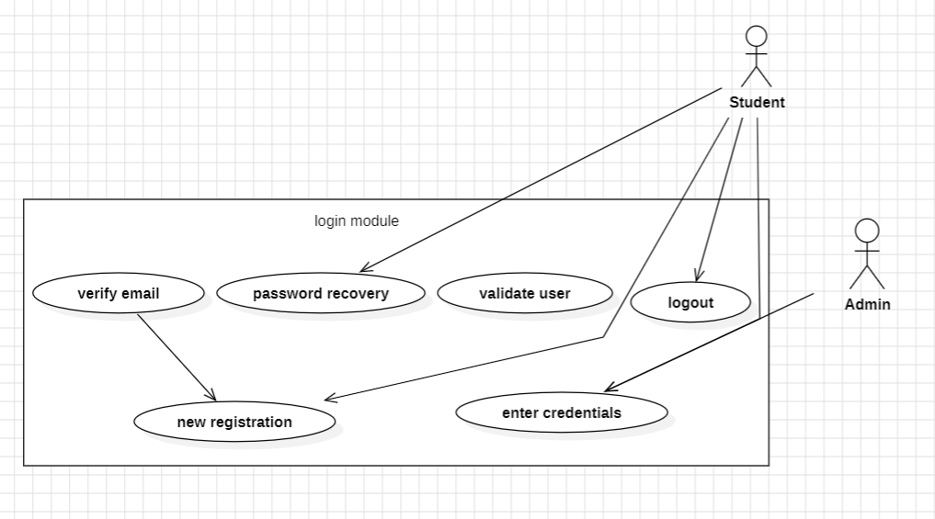
Description:
The diagram represents a Login Module of a system.
It shows how different users (Student and Admin) interact with the login-related functionalities such as:
- New Registration
- Verify Email
- Enter Credentials
- Validate User
- Password Recovery
- Logout
The student mainly interacts with all authentication-related actions, while the admin has limited interaction (such as logging in and logging out).

Primary Actors:
Primary actors are the main users who directly interact with the system to achieve their goals.
Student:
- Registers as a new user
- Verifies email
- Enters login credentials
- Gets validated by the system
- Uses password recovery
- Logs out of the system

Specialized Users:
Specialized users are actors with specific roles or higher privileges compared to regular users.
Admin:
- Has administrative access
- Can log in using credentials
- Can log out of the system
- Usually manages or monitors users (implicitly)
Admin is a specialized user with restricted but higher-level access compared to a student.

Secondary Actors:
Secondary actors support the system but do not directly initiate the main use cases.
Email Verification Service
- Supports the Verify Email use case
- Sends verification links or OTPs
Authentication System / Database
- Supports Validate User
- Stores and checks credentials
- Assists in Password Recovery
These actors are not shown explicitly but are assumed for system functioning.

ii)Use Case Diagram for Examination module:
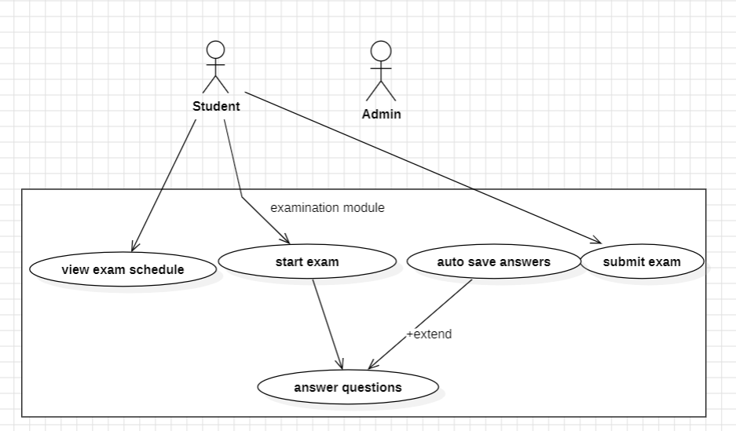
Description:
The image shows a Use Case Diagram for the Examination Module.
It explains how users interact with the exam-related functionalities of the system.
The module allows students to:
- View exam schedules

- Start the exam
- Answer questions
- Automatically save answers during the exam
- Submit the exam
The auto save answers use case extends the answer questions use case, meaning it works in the background while the student is answering questions.
The Admin interacts with the system mainly for examsubmission and management purposes.

Primary Actors:
Primary actors are the users who directly initiate and interact with the main system functions.
Student:
The Student is the main primary actor because they:
- View exam schedule
- Start the exam
- Answer questions
- Trigger auto-save while answering
- Submit the exam
Most use cases are centered around the Student.

Specialized Users:
Specialized users have specific roles or elevated responsibilities in the system.
Admin:
- Oversees the examination process
- Has authority related to exam submission and monitoring
- Interacts with the examination module at a higher control level
The Admin is considered a specialized user with administrative privileges.

Secondary Actors:
Secondary actors support the system operations but do not directly initiate the main use cases.
Auto-Save Service (Implied)
- Supports the auto save answers functionality
- Prevents data loss during the exam
Examination Database (Implied)
- Stores questions and answers
- Saves submitted exam data
- Helps retrieve exam schedules
Timer/System Scheduler (Implied)
- Manages exam duration
- Helps in auto-submission or time tracking
These actors are not shown explicitly but are essential for system execution.

iii)Use Case Diagram for QuestionBank module:
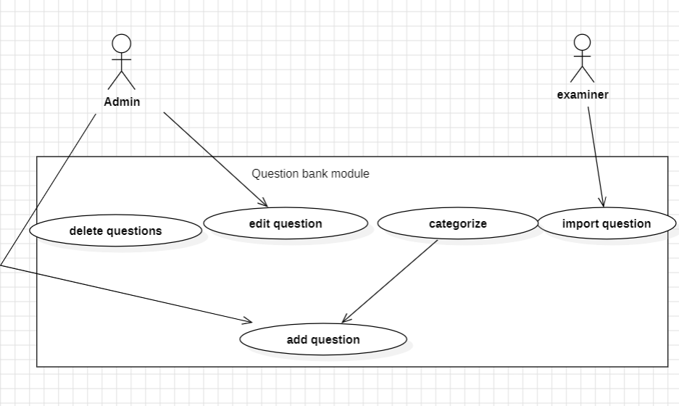

Description:
The diagram represents a Use Case Diagram for the Question Bank Module of an online examination system.
This module is used to manage exam questions. It allows authorized users to:
- Add new questions
- Edit existing questions
- Delete questions
- Categorize questions based on subject, difficulty, or topic
- Import questions in bulk
The Admin manages and controls most of the question bank operations, while the Examiner mainly contributes by importing questions into the system.

Primary Actors:
Primary actors are users who directly interact with the system to perform main functions.
Admin:
The Admin is the primary actor because they:
- Add questions to the question bank
- Edit questions
- Delete questions
- Categorize questions
Most use cases in this module are initiated by the Admin.

Specialized Users:
Specialized users have specific roles or limited, role-based access.
Examiner:
- Imports questions into the system
- Assists in building the question bank
- Has restricted access compared to Admin
The Examiner is a specialized user with a focused responsibility.

Secondary Actors:
Secondary actors support the system internally but do not directly initiate use cases.
Question Bank Database (Implied)
- Stores all questions and categories
- Supports add, edit, delete, and import operations
File Import Service (Implied)
- Handles bulk question upload (CSV, Excel, etc.)
- Supports the import question use case
Validation Engine (Implied)
- Checks question format, duplication, and correctness
These actors are not shown explicitly but are required for system functionality.

iv)Use Case Diagram for Evaluation module:
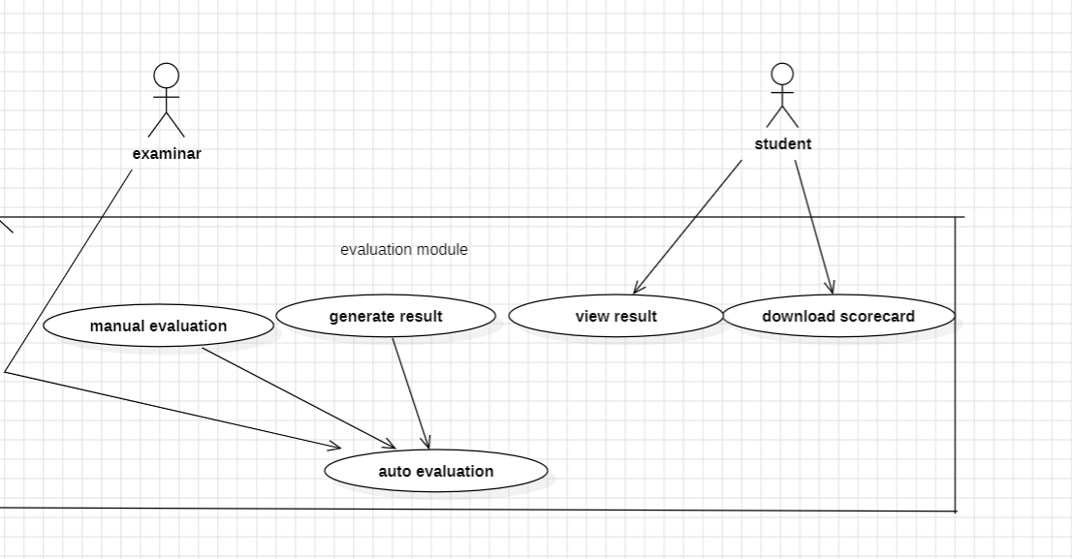
Description:
The diagram represents a Use Case Diagram for the Evaluation Module.
This module handles the assessment of student answers and result generation.
It supports:
- Manual evaluation of subjective answers by the examiner
- Automatic evaluation of objective answers by the system
- Result generation after evaluation
- Viewing results by students
- Downloading scorecards by students
Both manual and auto evaluation contribute to the final result generation.
Primary Actors:
Primary actors are users who directly interact with the system to achieve core objectives.
Examiner:
The Examiner is the primary actor because they:
- Perform manual evaluation
- Trigger or supervise auto evaluation
- Generate results
The evaluation process mainly depends on the Examiner’s actions.

Specialized Users:
Specialized users have role-specific access to the system.
Student:
- Views the examination result
- Downloads the scorecard
- Has read-only access to evaluation outcomes
The Student is a specialized user with limited access compared to the Examiner.

Secondary Actors:
Secondary actors support system operations but do not directly initiate use cases.
Evaluation Engine (Implied)
- Performs auto evaluation
- Calculates marks based on predefined rules
Result Processing System (Implied)
- Compiles scores
- Supports generate result functionality
Report / Scorecard Generator (Implied)
- Generates downloadable scorecards (PDF, etc.)
These actors are not explicitly shown but are essential for module functionality.

v)Use Case Diagram for User Management module:
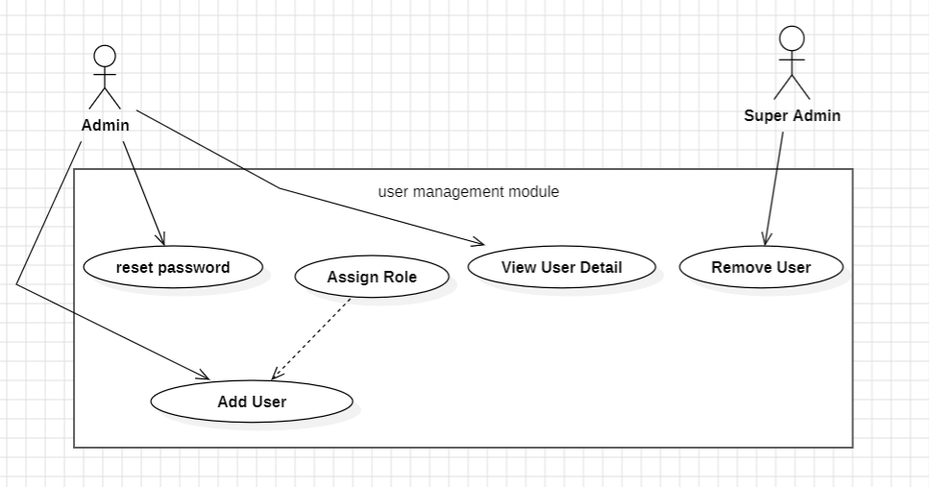
Description:
The diagram represents a Use Case Diagram for the User Management Module of an online examination system.
This module is responsible for managing system users and their access privileges. It allows authorized administrators to:
- Add new users to the system
- Assign roles to users
- View user details
- Reset user passwords
- Remove users from the system
The Assign Role use case is related to Add User, indicating that roles are assigned when a new user is created.
The Super Admin has higher authority and can remove users from the system.

Primary Actors:
Primary actors are users who directly interact with the system to perform main operations.

Admin:
The Admin is the primary actor because they:
- Add new users
- Assign roles to users
- Reset passwords
- View user details
Most user-management activities are initiated by the Admin.

Specialized Users:
Specialized users have higher privileges or specific administrative authority.
Super Admin:
- Removes users from the system
- Has full control over user accounts
- Oversees administrative actions
The Super Admin is a specialized user with the highest level of access.

Secondary Actors:
Secondary actors support system functions but do not directly initiate use cases.
User Database (Implied)
- Stores user details, roles, and credentials
- Supports add, view, reset, and remove operations
Authentication / Security Service (Implied)
- Handles password reset
- Ensures secure role assignment
Notification Service (Implied)
- Sends emails or alerts for password resets or account changes
These actors are not explicitly shown but are essential for system operation.

vi)Use Case Diagram for Proctoring module:
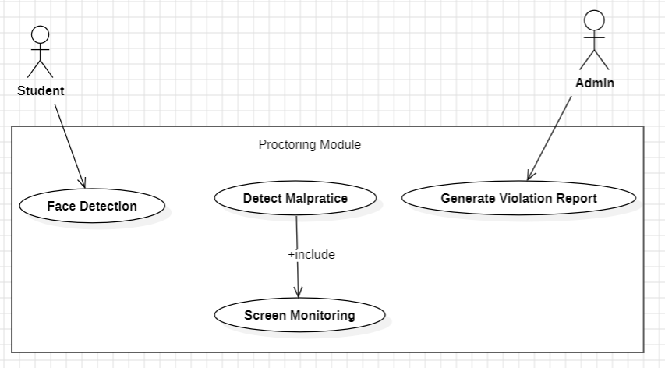
Description:
The diagram shows a Use Case Diagram for the Proctoring Module, which ensures fairness and integrity during online examinations.
This module monitors students during an exam by:
- Performing face detection to verify the student’s presence
- Detecting malpractice such as unauthorized activities
- Screen monitoring as part of malpractice detection (included use case)
- Generating violation reports for administrative review
The Detect Malpractice use case includes Screen Monitoring, indicating that screen monitoring is a mandatory part of malpractice detection.
The Admin reviews and generates violation reports, while the student is monitored during the exam.

2. Primary Actors
Primary actors are those who directly interact with the core functionalities.
Student:
The Student is the primary actor because:
- Face detection is performed on the student
- The student is the subject of monitoring during the exam
The proctoring process primarily revolves around the student’s activity.

Specialized Users:
Specialized users have supervisory or administrative authority.
Admin:
- Generates and reviews violation reports
- Oversees proctoring outcomes
- Takes action based on detected malpractice
The Admin is a specialized user with control and monitoring privileges.

Secondary Actors:
Secondary actors support the system technically but do not directly initiate use cases.
Face Recognition System (Implied)
- Supports Face Detection
- Verifies identity using camera input
Screen Monitoring Service (Implied)
- Tracks screen activity during the exam
- Supports the Detect Malpractice use case
AI / Proctoring Engine (Implied)
- Analysesbehaviour and detects suspicious activities
- Triggers malpractice alerts
Reporting System (Implied)
- Generates violation reports in structured format
These actors are not explicitly shown but are essential for module functionality.

Class Diagram:
i)Class Diagram for login module:
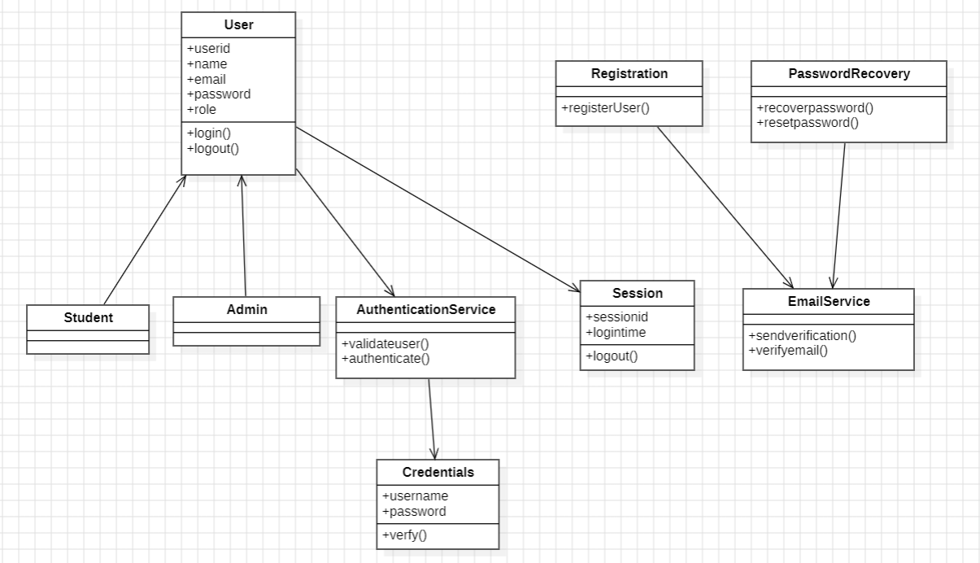

Purpose: A secure authentication and user management system for educational platforms that handles registration, login and role-based access control for students and administrators.
Key Functions:
- User registration with email verification
- Secure login/logout with session tracking
- Role-based authentication (Student/Admin)
- Credential verification and validation
- Session lifecycle management
ii)Class Diagram for Examination module:
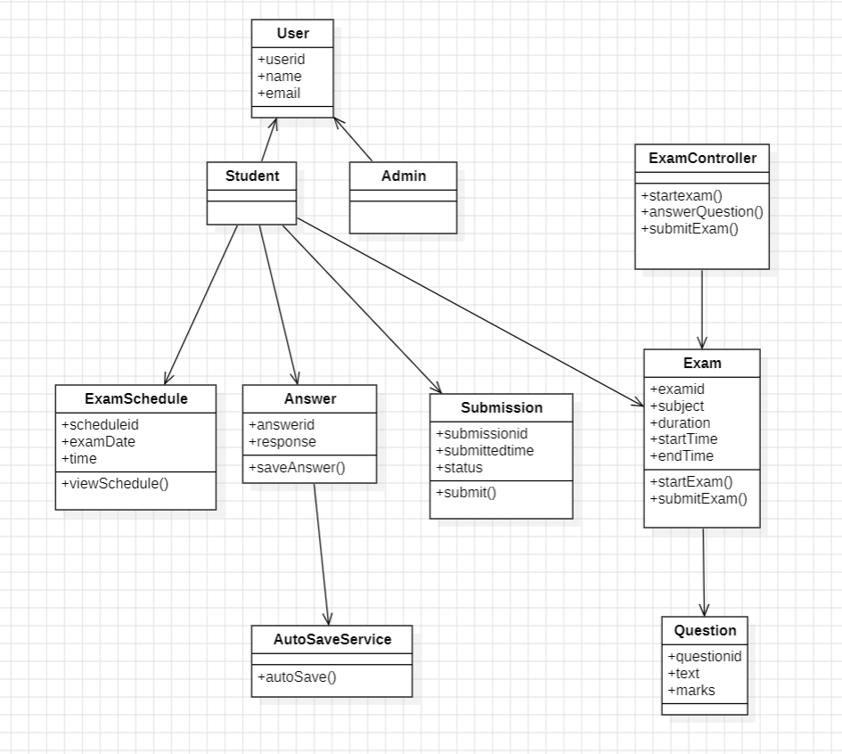
Purpose: An online examination system that manages exam scheduling, question answering, submission and auto-saving for students under administrative oversight.
Key Functions:
- Exam scheduling and timeline management
- Question answering with auto-save functionality
- Exam submission with status tracking
- Student answer recording and saving
- Exam lifecycle control (start to submit)

iii)Class Diagram for QuestionBank module:
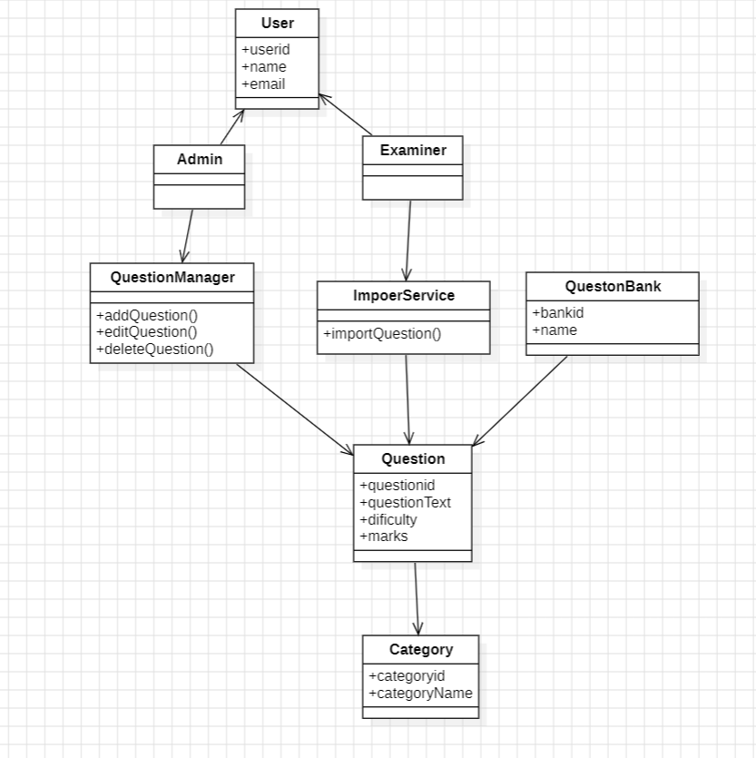

Purpose: A question bank management system for creating, organizing and importing examination questions by category and difficulty level.
Key Functions:
- Add, edit and delete questions
- Categorize questions by subject/type
- Import questions from external sources
- Organize questions by difficulty level
- Admin/examiner role-based management.

iv)Class Diagram for Evaluation module:
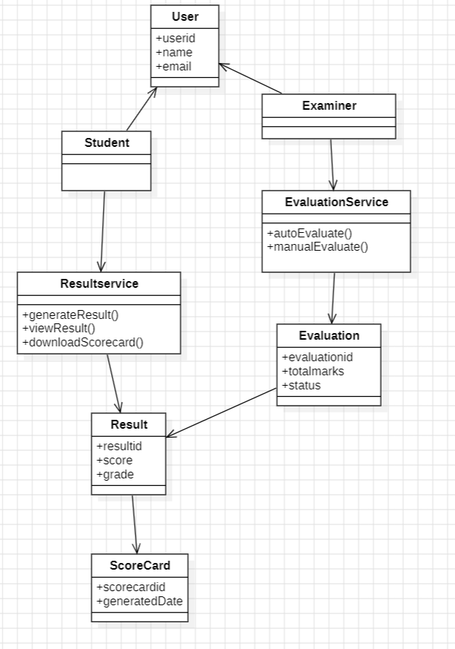
Purpose: An automated and manual evaluation system that grades exams, generates results and produces scorecards for students.
Key Functions:
- Automated and manual exam evaluation
- Result generation with scores and grades
- Scorecard creation and downloading
- Result viewing and status tracking
- Role-based access for students and examiners

v)Class Diagram for User Management module:
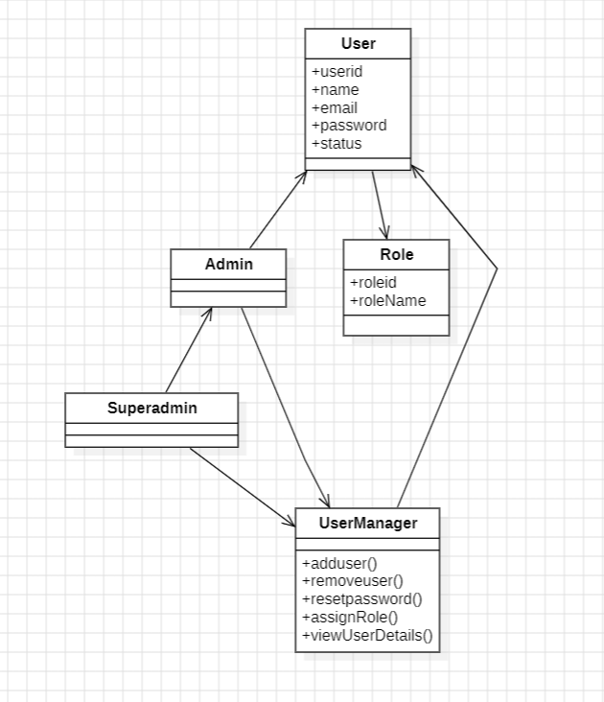
Purpose: A user management and role assignment system for administrators and superadmins to control user access and permissions.
Key Functions:
- Add and remove user accounts
- Assign and manage user roles
- Reset user passwords
- View detailed user information
- Control user status and access levels

vi)Class Diagram for Proctoringmodule:
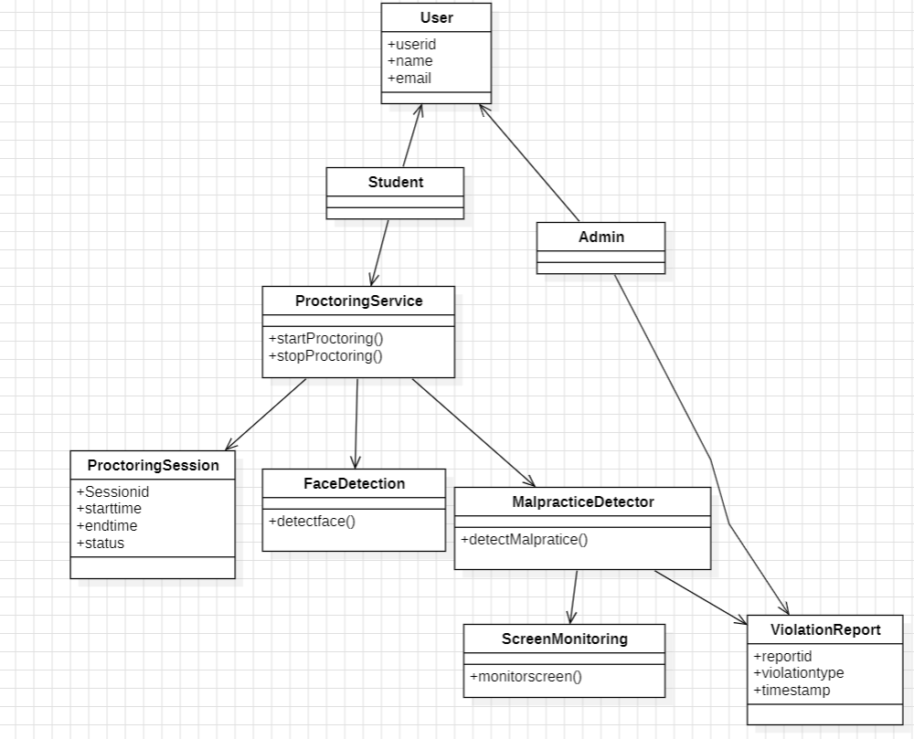
Purpose: An automated online exam proctoring system that monitors students for malpractice through face detection and screen monitoring.
Key Functions:
- Real-time face detection during exams
- Screen monitoring for suspicious activities
- Malpractice detection and violation reporting
- Proctoring session start/stop management
- Violation logging with timestamps and types

State Chart Diagram:
State Chart Diagram for Proctoring module:
i)State Chart Diagram for ProctoringService class:
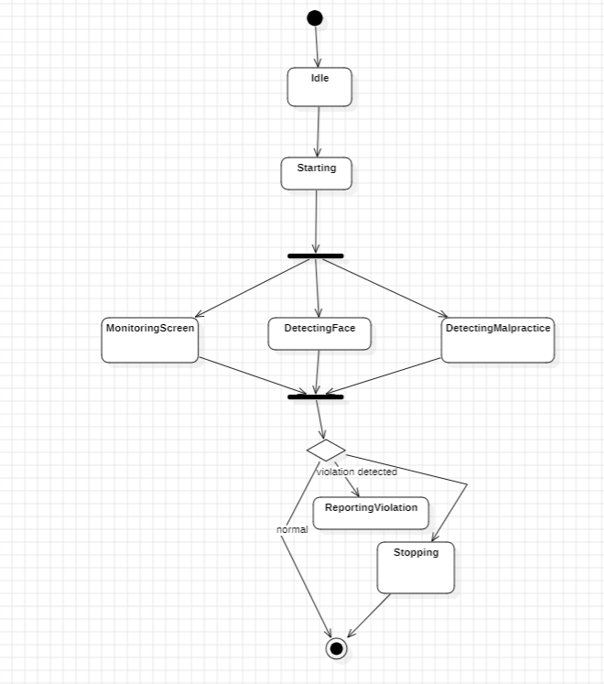
- Admin Authentication Required: The workflow begins with an administrator logging into the system to access user management functions.
- Multiple User Management Options: Admin can choose between resetting passwords, assigning roles, viewing user details, or adding/removing users.
- Conditional User Addition: The system prompts whether to add a new user; if "yes," proceeds to add, if "no," skips to remove user function.
- Sequential Operation Flow: Operations follow a logical sequence from viewing/modifying existing users to potentially adding new ones and then removing users.
- Comprehensive User Lifecycle Management: The process covers the complete user lifecycle including creation, modification and removal of user accounts.

ii)State Chart Diagram for ProctoringSession class:
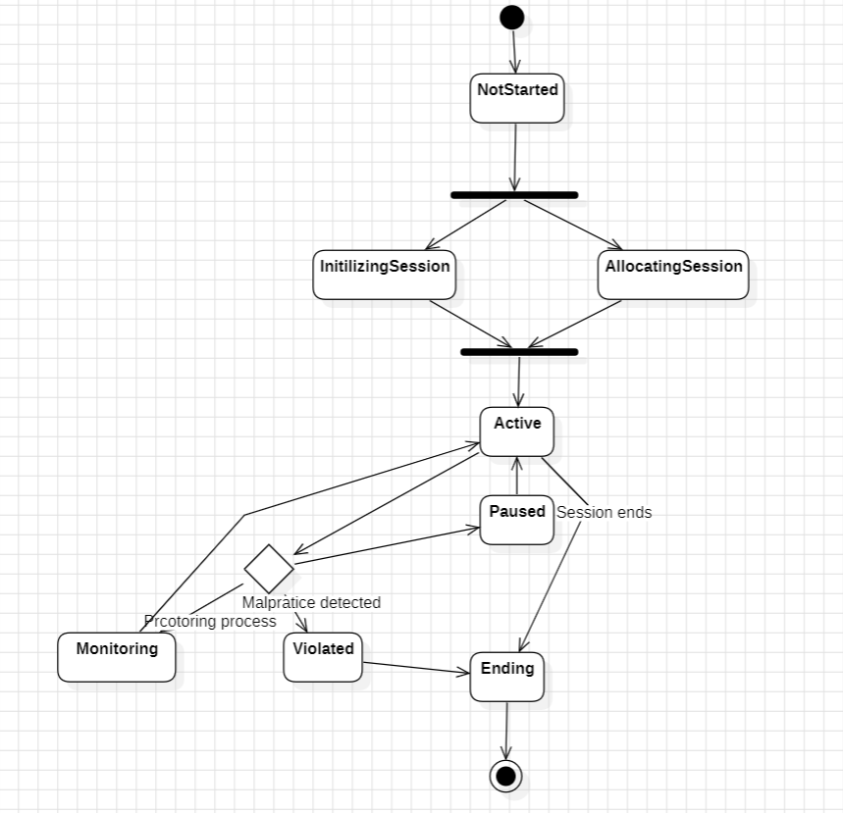

- Progressive Session Lifecycle: The session follows a sequential flow from "NotStarted" through initialization, activation, and monitoring to final termination.
- Real-Time Monitoring System: Once active, the session enters a continuous "Monitoring" state for ongoing surveillance during exams.
- Malpractice Detection Integration: The system includes a "Violated" state specifically triggered when malpractice is detected during monitoring.
- User Break Accommodation: Includes a "Paused" state to accommodate legitimate breaks during proctored sessions.
- Controlled Termination Process: Sessions end through a structured "Ending" state rather than abrupt termination, ensuring proper closure.

iii)State Chart Diagram for ViolationReport class:
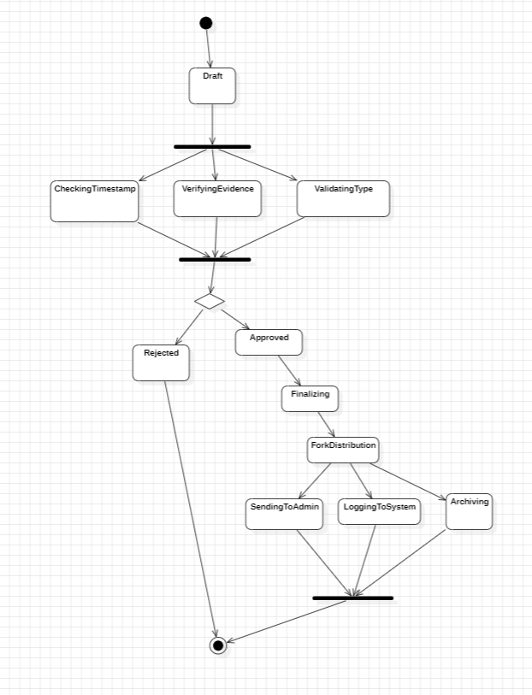
- Structured Validation Process: Violation reports go through three parallel validation checks (timestamp verification, evidence verification, and type validation) simultaneously.
- Binary Outcome Paths: Reports have only two possible validation outcomes - "Approved" for valid data or "Rejected" for invalid data.
- Multi-Channel Distribution: Approved reports are distributed through three parallel channels: admin notification, system logging, and secure archiving.
- Sequential Workflow: The process follows a logical sequence from draft creation → parallel validation → decision → finalization → distribution.
- Comprehensive Documentation: The workflow ensures complete documentation trail from initial draft through validation to permanent archival.

Activity Diagram:
i)Activity Diagram for Proctoring module:
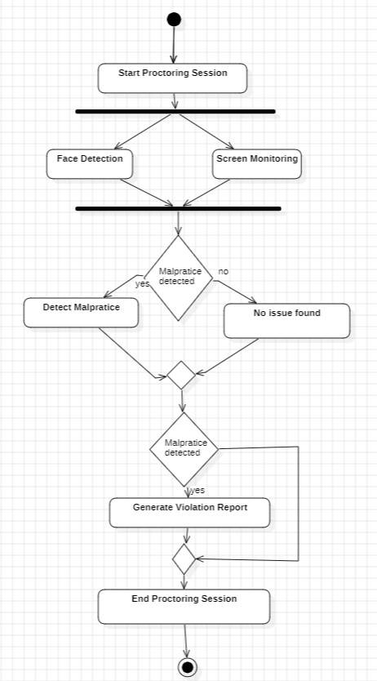
- Dual-Monitoring System: The proctoring session simultaneously runs both Face Detection and Screen Monitoring for comprehensive surveillance.
- Continuous Malpractice Checking: The system continuously checks for malpractice during both monitoring processes in parallel.
- Conditional Report Generation: Violation reports are only generated when malpractice is detected, otherwise the session continues monitoring.
- Two-Stage Detection Process: Malpractice detection occurs at two points - during initial monitoring and after deeper analysis if suspicious activity is found.
- Structured Session Management: The workflow follows a clear start → monitor → check → report → end sequence for controlled proctoring execution.

ii)Activity Diagram for User Management module:
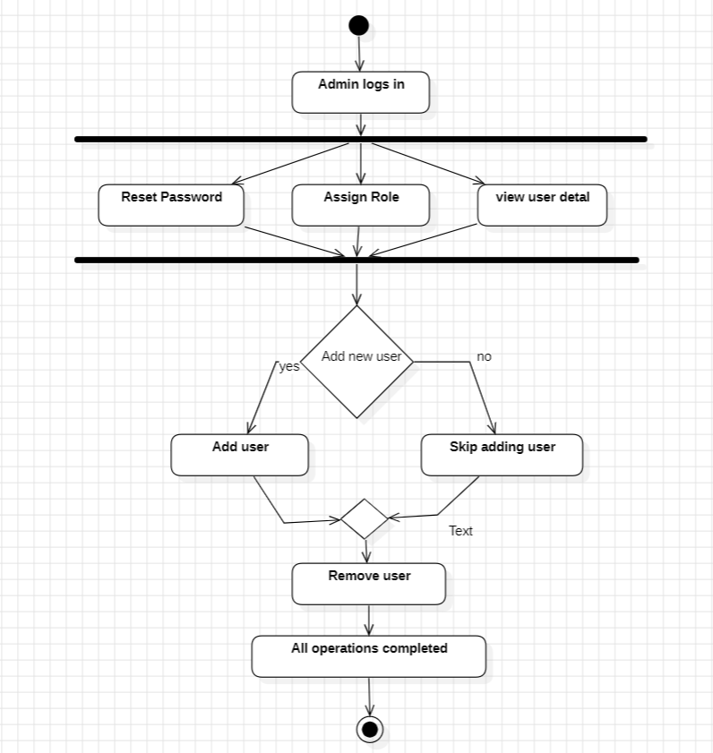
- Role-Based Access Control: The system enforces administrative privileges, requiring admin login before accessing user management functions.
- Multiple Concurrent Options: Admins can perform various user operations including password reset, role assignmentand viewing user details.
- Conditional User Addition: The workflow includes a decision point where admins choose whether to add new users, accommodating different administrative scenarios.
- Comprehensive User Lifecycle: The process covers the complete user management cycle from creation (Add user) to maintenance (Reset/Assign) to removal (Remove user).
- Structured Workflow Completion: The system follows a logical sequence ending with "All operations completed," ensuring proper closure of administrative tasks.

Sequence Diagram:
i)Sequence DiagramforExamination module:
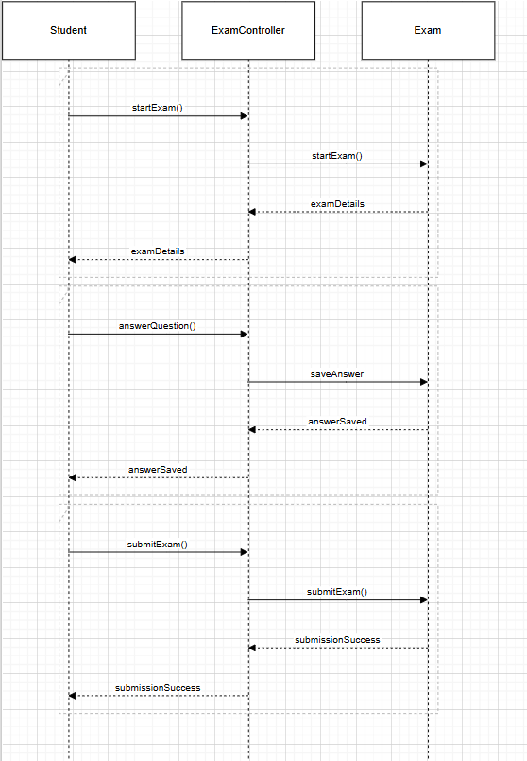

ii)Sequence Diagram forQuestionBank module:
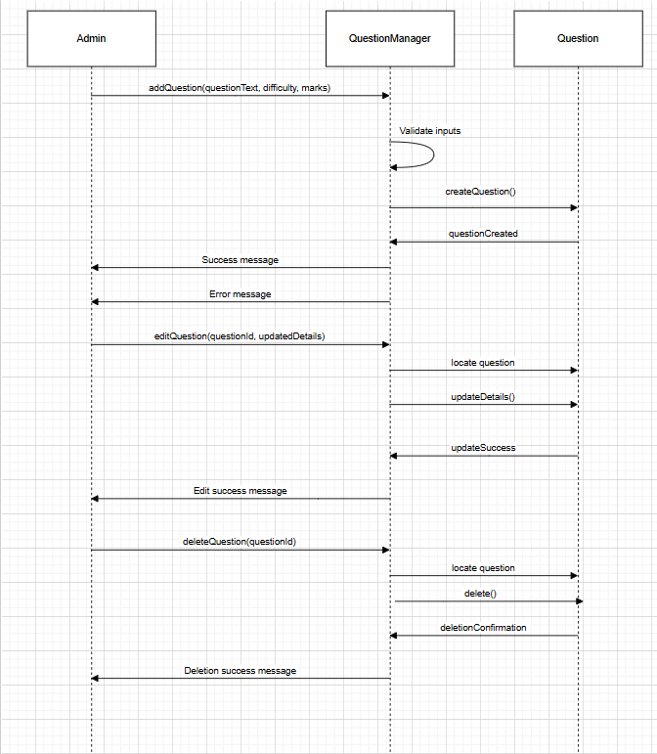

iii)Sequence Diagram for Proctoring module:
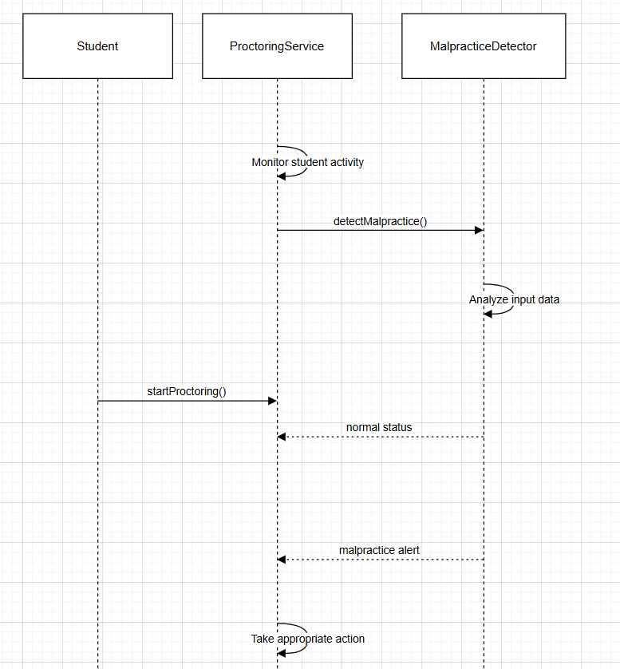

Collaboration Diagrams:
i)Collaboration Diagram for Examination module:
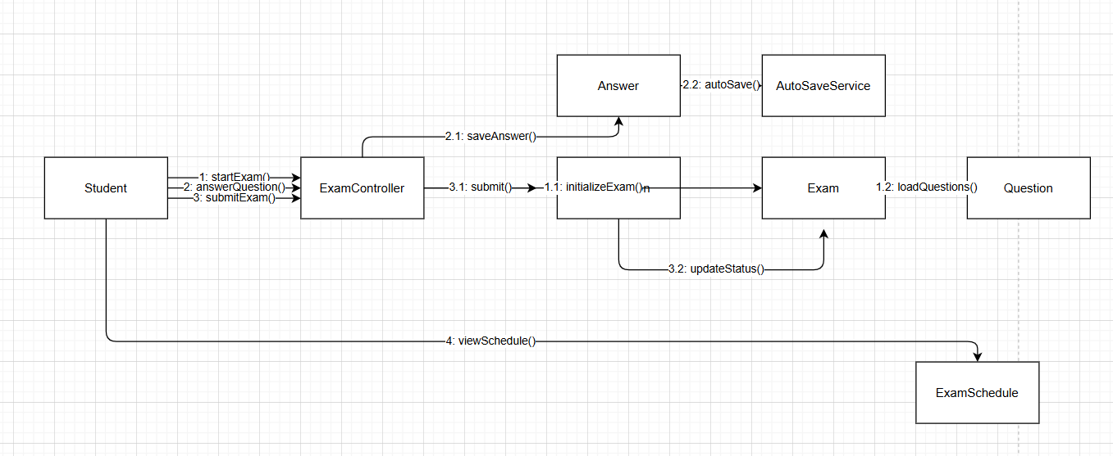

ii)Collaboration Diagram for QuestionBank module:
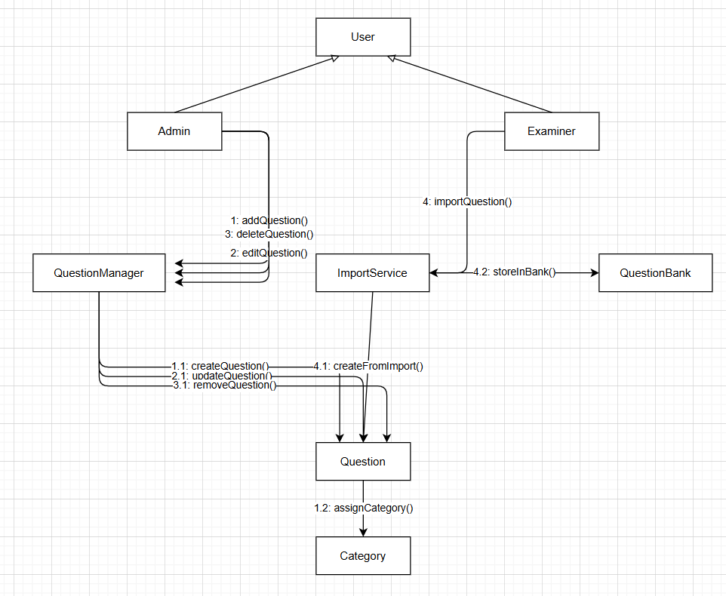

iii)Collaboration Diagram for Proctoring module:
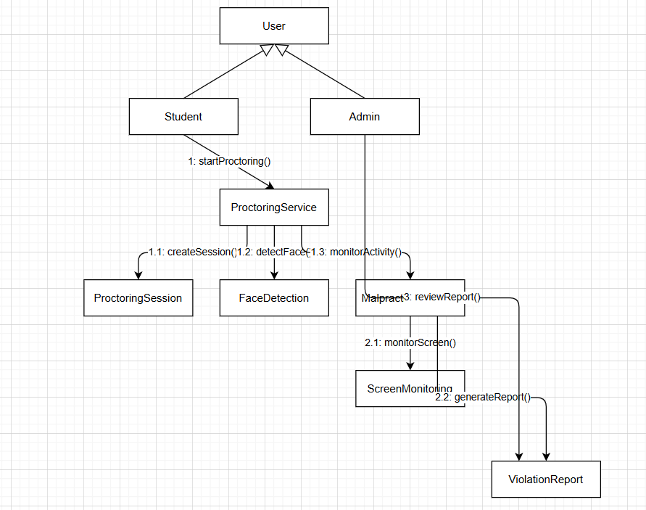

3.2 ER Diagram
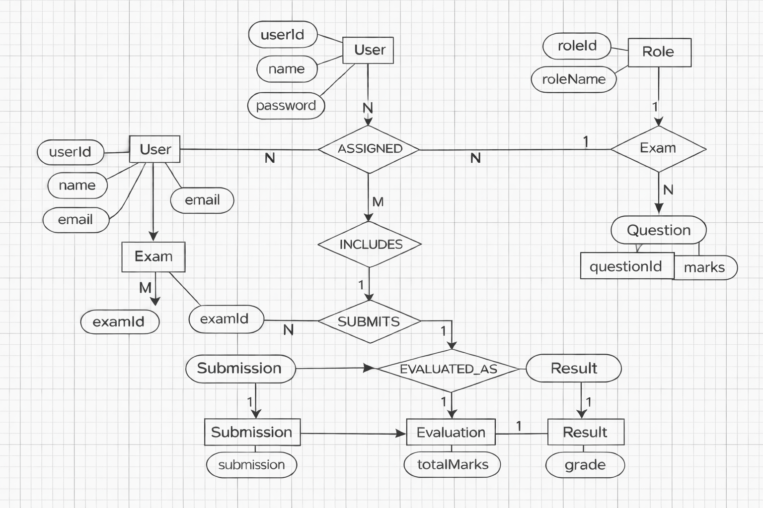

  - DFD Diagram
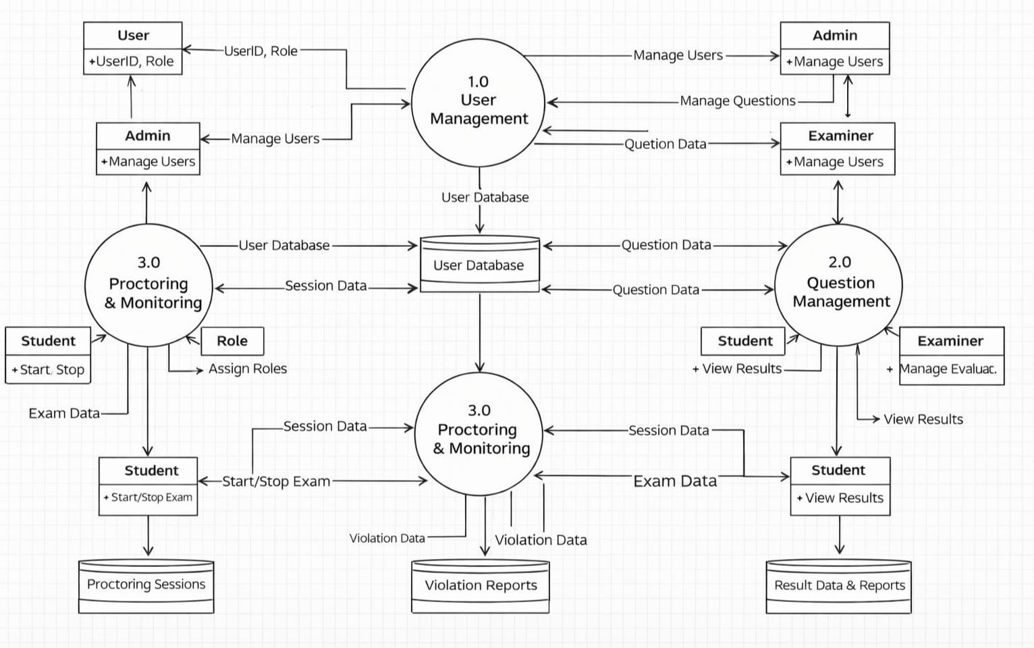

4.External Interface Requirements

4.1 User Interface
The Online Examination System provides role-based user interfaces designed for clarity, security and ease of use.
4.1.1 Student Interface
The Student interface allows users to:
- Register and log in using secure credentials
- Perform identity verification using the system camera before the exam
- View scheduled examinations and instructions
- Attempt exams within the allocated time
- Navigate between questions
- Submit answers securely
- View results after evaluation
4.1.2 Examiner Interface
The Examiner interface allows users to:
- Log in using authorized credentials
- Create, update and delete questions in the question bank
- Define question types, marks and difficulty levels
- Schedule examinations and set time limits
- View student responses and submissions
- Evaluate answers and assign marks
- Generate performance and evaluation reports

4.1.3 Administrator Interface
The Administrator interface shall allow users to:
- Manage users, roles and permissions
- Enable or disable camerabased verification
- Monitor exam sessions and suspicious activities
- View system logs and audit trails
- Manage backups and system configurations

4.2 Hardware Interface
This section describes the hardware components required to interact with the system.
The system can be accessed using desktop computers, laptops, tablets and smartphones.
Input devices include:
- Keyboard (for typing answers)
- Mouse or touch interface (for navigation)
Output devices include:
- Monitor or display screen for viewing questions and results
A central server machine is required to:
- Host the application
- Store exam and user data
- Handle concurrent user requests
The system does not require specialized hardware such as cameras, biometric sensors, GPS or RFID devices.

4.3 Software Interface
- The system supports operating systems such as Windows, Linux, and macOS, and can be accessed using modern web browsers like Chrome, Firefox and Edge.
- A relational database such as MySQL is used to store user information, question bank data, exam schedules, student responses and evaluation results securely.
- REST-based APIs are used for user authentication, exam management, submission processing and data exchange between the frontend and backend.
- The system interacts with external software such as camera access services and proctoring or authentication APIs to verify user identity and ensure exam integrity.

4.4 Communication Interface
This section explains how data is exchanged across networks.
The system uses the Internet to allow remote access by users.
Communication is performed using:
- HTTP for standard communication
- HTTPS for secure data transmission
The system follows a clientserver architecture.
Data exchange includes:
- Login credentials
- Exam questions
- Student answers
- Results and reports
The system supports connectivity over:
- LAN (Local Area Network)
- Wi-Fi networks
Security mechanisms such as encryption and authentication are used to protect data during transmission.

5.OtherNon-FunctionalRequirements

5.1 Performance Requirements
The Online Examination System shall meet the following performance criteria:
- The system shall respond to user actions (login, question loading, submission) within 2 seconds under normal operating conditions.
- The system shall support multiple concurrent users without performance degradation.
- The system shall handle high load during peak examination hours.
- The system shall ensure smooth navigation between questions with minimal latency.
- The system shall maintain consistent performance throughout the examination duration.

5.2 Safety Requirements
Safety requirements focus on preventing data loss, corruption and system failure.
- The system shall perform regular backups of examination data and user responses.
- Automatic data saving shall occur at regular intervals during the exam.
- The system shall support recovery mechanisms in case of system crash or network failure.
- Error handling mechanisms shall notify users of failures without loss of data.
- The system shall maintain exam state to allow session restoration if interrupted.
5.3 Security Requirements
Security requirements ensure the confidentiality, integrity and authenticity of data.
- The system shall allow access only to authenticated users.
- Role-based authorization shall restrict access based on user type (student, examiner, administrator).
- User credentials and sensitive data shall be protected using data encryption.
- Camera-based identity verification shall ensure the correct candidate attempts the exam.
- The system shall prevent unauthorized access, impersonation and data tampering.

5.4 Software Quality Attributes
The Online Examination System shall exhibit the following quality characteristics:
- Reliability: The system shall operate continuously without unexpected failures during exams.
- Usability: The system shall be easy to learn and use for all users.
- Scalability: The system shall support an increasing number of users without major redesign.
- Maintainability: The system shall be easy to update, debug and enhance.
- Availability: The system shall be available during scheduled examination periods.

5.5 Business Policies / Rules
The system shall comply with institutional and legal policies:
- The system shall follow college or university examination rules.
- Examination duration and attempt limits shall be enforced as per institutional guidelines.
- User data shall be handled according to data protection and privacy laws.
- The system shall maintain logs for audit and compliance purposes.

6.Testing

6.1 White-Box Testing

i)White-Box Testing for Examination Module:

Python Code of Examination Module:
from flask import Flask, render_template, request

app = Flask(__name__)

# Questions database

questions = [
{"id": 1, "question": "What is 2+2?", "options": ["2","3","4","5"]},
{"id": 2, "question": "Capital of India?", "options": ["Mumbai","Delhi","Chennai","Kolkata"]},
{"id": 3, "question": "Which data structure uses FIFO?", "options": ["Stack","Queue","Tree","Graph"]}
]

student_answers = {}

@app.route("/")

def start_exam():

return render_template("exam.html", questions=questions)

@app.route("/submit_exam", methods=["POST"])
def submit_exam():

for q in questions:
ans = request.form.get(str(q["id"]))
student_answers[q["id"]] = ans
return render_template("submitted.html", answers=student_answers)

if __name__ == "__main__":
app.run(debug=True)

Flow Graph Notation:

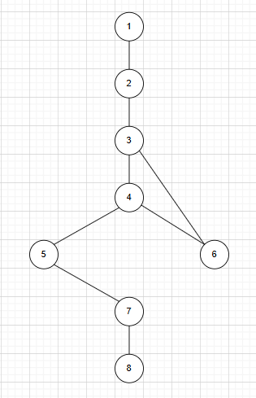

This flowchart represents the step-by-step process of an online examination system. It begins with the Start node, where the exam is initiated. Next, the system displays the questions to the student. The student then selects an answer for the current question. After each answer, the system checks if there are more questions left. If yes, it loops back for the student to select another answer. If no, the student proceeds to submit the exam. The system then stores all the answers in memory, and finally, the process ends with a confirmation page showing the submitted answers.

Graph Matrix:

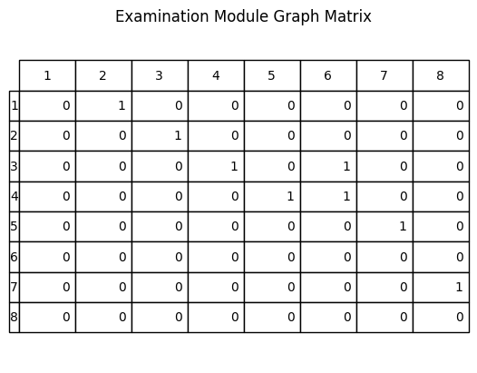

Cyclomatic Complexity:
Cyclomatic Complexity Formula:
- V(G)=E-N+2
- V(G) = Cyclomatic Complexity
- E = Number of Edges
- N = Number of Nodes
In this Flowchart image the values of N is 7 and E is 8. So,The Cyclomatic Complexity will be 3.
V(G)=3.

Independent Program Paths:
As we got the Cyclomati Complexity value as 3 we will get three paths they are
Path 1: 1 → 2 → 3 → 4 → 5 → 6 → 7
Path 1 – No Loop Iteration → All questions answered in one go
Path 2: 1 → 2 → 3 → 4 → 3 → 4 → 5 → 6 → 7
Path 2 – One Loop Iteration → One question revisited
Path 3: 1 → 2 → 3 → 4 → 3 → 4 → 3 → 4 → 5 → 6 → 7
Path 3 – Two Loop Iterations → Two questions revisited

Independent Paths And Tests:
Path No | Independent Path | Test Input | Expected Output
P1 | 1 → 2 → 3 → 4 → 5 → 6 → 7 | Student answers all questions and clicks submit | Answers stored successfully and exam submitted
P2 | 1 → 2 → 3 → 4 → 3 → 4 → 5 → 6 → 7 | Student answers first question, moves to next question, then submits | System allows answering multiple questions and stores answers
P3 | 1 → 2 → 3 → 4 → 3 → 4 → 3 → 4 → 5 → 6 → 7 | Student answers several questions before submission | All answers recorded and exam submitted successfully

import unittest
from app import app, student_answers, questions
class TestOnlineExam(unittest.TestCase):

def setUp(self):
self.client = app.test_client()
student_answers.clear()

def test_all_questions_answered(self):
self.client.post("/submit_exam", data={str(q["id"]): q["options"][2] for q in questions})
self.assertEqual(len(student_answers), len(questions))

def test_first_question_only(self):
self.client.post("/submit_exam", data={str(questions[0]["id"]): questions[0]["options"][2]})
self.assertIn(questions[0]["id"], student_answers)

def test_several_questions(self):
self.client.post("/submit_exam", data={str(questions[i]["id"]): questions[i]["options"][1] for i in range(2)})

self.assertEqual(len(student_answers), 2)

if __name__ == "__main__":
unittest.main()

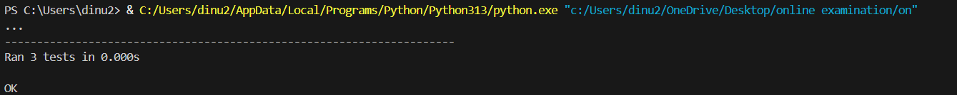

All tests passed So, white-box testing is Successful.

ii)White-Box Testing for Evaluation Module:

Python Code of Evaluation Module:
from flask import Flask, request, jsonify
app = Flask(__name__)
correct_answers = {
"q1": "A",
"q2": "B",
"q3": "C",
"q4": "D",
"q5": "A"}

@app.route('/evaluate', methods=['POST'])
def evaluate():
data = request.json

student_answers = data["answers"]
score = 0
total = len(correct_answers)

for q in correct_answers:
if q in student_answers:
if student_answers[q] == correct_answers[q]:
score += 1

result = {
"score": score,
"total": total,
"percentage": (score / total) * 100 }
return jsonify(result)

if __name__ == '__main__':
app.run(debug=True)

Flow Graph Notation:
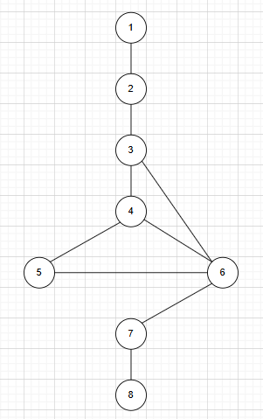
This flowchart illustrates the automated answer evaluation process in an examination system. It begins at the Start node, where the evaluation module is initiated. The system then receives the student'sanswers from the submission. Each answer is compared with the correct answer stored in the database. A decision point checks if the answer is correct .If yes, the system updates the score accordingly; if no, it skips the score update. After handling correctness, the system checks if there are more questions to evaluate. If yes, it loops back to compare the next answer. If no more questions remain, it proceeds to generate the final result and finally, the process ends.

Graph Matrix:
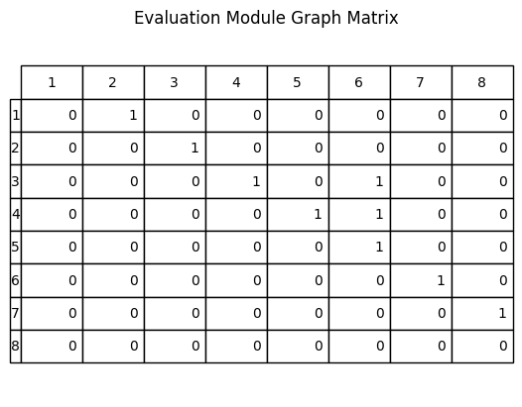

Cyclomatic Complexity:
Cyclomatic Complexity Formula:
- V(G)=E-N+2
- V(G) = Cyclomatic Complexity
- E = Number of Edges
- N = Number of Nodes
In this Flowchart image the values of N is 8 and E is 10. So,The Cyclomatic Complexity will be .
V(G)=4.

Independent Program Paths:
As we got the Cyclomati Complexity value as 3 we will get three paths they are
Path 1: 1 → 2 → 3 → 4 → 5 → 6 → 7 → 8
Path 1 – Student answers correctly and no more questions remain
Path 2: 1 → 2 → 3 → 4 → 6 → 7 → 8
Path 2 – Student answers incorrectly and no more questions remain
Path 3: 1 → 2 → 3 → 4 → 5 → 6 → 3 → 4 → 6 → 7 → 8
Path 3 – Student answers first question correctly, second question incorrectly, then evaluation ends
Path 4: 1 → 2 → 3 → 4 → 6 → 3 → 4 → 5 → 6 → 7 → 8
Path 4 – Student answers first question incorrectly, second question correctly, then evaluation ends

Independent Paths And Tests:
Path No | Independent Path | Test Input | Expected output
P1 | 1 → 2 → 3 → 4 → 5 → 6 → 7 → 8 | Student answers are correct | Score increases and result generated
P2 | 1 → 2 → 3 → 4 → 6 → 7 → 8 | Student answers are incorrect | Score not increased and result generated
P3 | 1 → 2 → 3 → 4 → 5 → 6 → 3 → 4 → 6 → 7 → 8 | Multiple questions with some correct answers | Score updated for correct answers
P4 | 1 → 2 → 3 → 4 → 6 → 3 → 4 → 5 → 6 → 7 → 8 | Multiple questions with mixed answers | Correct answers counted and final result generated

import unittest, json
from evaluation import app

class TestEvaluation(unittest.TestCase):

def setUp(self):
self.client = app.test_client()

def check_score(self, answers, expected):
r = self.client.post('/evaluate',
data=json.dumps({"answers": answers}),
content_type='application/json')
self.assertEqual(json.loads(r.data)["score"], expected)

def test_all_correct(self):
self.check_score({"q1":"A","q2":"B","q3":"C","q4":"D","q5":"A"}, 5)

def test_all_incorrect(self):
self.check_score({"q1":"B","q2":"A","q3":"A","q4":"A","q5":"B"}, 0)

def test_some_correct(self):
self.check_score({"q1":"A","q2":"B","q3":"A","q4":"A","q5":"B"}, 2)

def test_mixed(self):
self.check_score({"q1":"A","q2":"C","q3":"C","q4":"D","q5":"B"}, 3)

if __name__ == "__main__":
unittest.main()
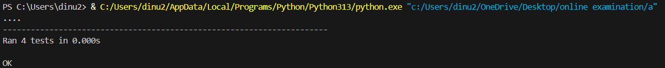

All tests passed So, white-box testing is Successful.

6.2 Black-Box Testing

i)Black-Box Testing for Examination Module:

Python Code of Examination Module:
from flask import Flask, render_template, request
app = Flask(__name__)

# Questions database
questions = [
{"id": 1, "question": "What is 2+2?", "options": ["2","3","4","5"]},
{"id": 2, "question": "Capital of India?", "options": ["Mumbai","Delhi","Chennai","Kolkata"]},
{"id": 3, "question": "Which data structure uses FIFO?", "options": ["Stack","Queue","Tree","Graph"]}

]
student_answers = {}

@app.route("/")
def start_exam():
return render_template("exam.html", questions=questions)

@app.route("/submit_exam", methods=["POST"])
def submit_exam():

for q in questions:
ans = request.form.get(str(q["id"]))
student_answers[q["id"]] = ans

return render_template("submitted.html", answers=student_answers)

if __name__ == "__main__":
app.run(debug=True)

Step1:Write Functional Requirements:
- The system should display exam questions with multiple-choice options to the student.
- The system should allow the student to select one answer for each question.
- The system should accept the student’s answers through a form submission.
- The system should store the answers submitted by the student.
- The system should process the submitted answers on the server side.
- The system should display the submitted answers to the student after the exam is completed.

Step2: Black Box Testing Techniques:

Equivalence Partitioning:
Divide inputs into logical groups:

For Question Selection:
Class | Condition | Valid/Invalid
EC1 | Student selects a valid option for Question 1 | Valid
EC2 | Student selects an option not present in Question 1 | Invalid
EC3 | Student does not select any option for Question 1 | Invalid

For Multiple Questions:
Class | Condition | Valid/Invalid
EC4 | Student answers all questions correctly | Valid
EC5 | Student answers some questions | Valid
EC6 | Student does not answer any question | Invalid

For Exam Submission:
Class | Condition | Result
EC7 | All answers submitted properly | Exam Submitted Successfully
EC8 | Some answers missing | Partial Submission
EC9 | No answers submitted | Submission Failed / Empty Answers
EC10 | Invalid data sent in request | Error / Invalid Input

Boundary Value Analysis:

Boundary Values for Number of Questions Answered:
BB No | Test Value | Type | Expected Output
BB4 | 0 answers submitted | Invalid(Below Minimum) | Empty answers displayed
BB5 | 1 answers submitted | Valid(Minimum) | Partial answers displayed
BB6 | 3 answers submitted | Valid(Exact Boundary) | All answers displayed correctly

Boundary Values for Question Answer Selection:
BB No | Test Value | Type | Expected Output
BB1 | No option selected for Question 1 | Invalid (Below minimum) | Answer stored as None
BB2 | One valid option selected (e.g., "4") | Valid (Minimum) | Answer stored successfully
BB3 | Option outside given list (e.g., "10") | Invalid | Incorrect answer stored / validation error

Combined Boundary Test Cases:
BB No | Q1 Answer | Q2 Answer | Q3 Answer | Type | Expected Output
BB7 | None | None | None | Below Boundary | No answers submitted
BB8 | “4” | None | None | Partial Submission | Only Q1 answer stored
BB9 | “4” | “Delhi” | None | Partial Submission | Two answers stored
BB10 | “4” | “Delhi” | “Queue” | Exact Boundary Valid | All answers displayed correctly
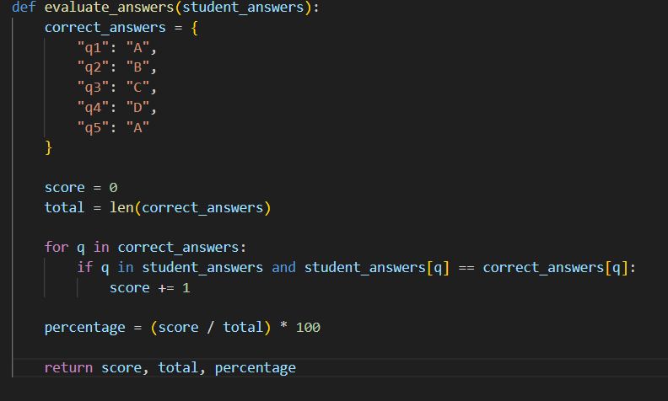

The Output is matched to all the above test cases mentioned in table, then Black Box testing is successful.
ii)Black-Box Testing for Evaluation Module:

Python Code of Evaluation Module:
from flask import Flask, request, jsonify

app = Flask(__name__)

# Correct answers stored in dictionary
correct_answers = {
"q1": "A",
"q2": "B",
"q3": "C",
"q4": "D",
"q5": "A"
}
@app.route('/evaluate', methods=['POST'])
def evaluate():
data = request.json
student_answers = data["answers"]
score = 0
total = len(correct_answers)
for q in correct_answers:
if q in student_answers:
if student_answers[q] == correct_answers[q]:
score += 1
result = {
"score": score,
"total": total,
"percentage": (score / total) * 100
}
return jsonify(result)
if __name__ == '__main__':
app.run(debug=True)

Step1:Write Functional Requirements:
- The system should receive student answers through the /evaluate API.
- The system should store the correct answers for all questions.
- The system should compare student answers with correct answers.
- The system should calculate the student score.
- The system should calculate the percentage of marks.
- The system should display the evaluation result (score, total, percentage).

Step2: Black Box Testing Techniques:

Equivalence Partitioning:
Divide inputs into logical groups:

For Student Answers Input:
Class | Condition | Valid/Invalid
EC1 | Student submits answers for all questions (q1–q5) | Valid
EC2 | Student submits answers for some questions only | Valid
EC3 | Student submits no answers | Invalid

For Answer Correctness:
Class | Condition | Valid/Invalid
EC4 | Student answer matches the correct answer | Valid
EC5 | Student answer does not match the correct answer | Invalid
EC6 | Question key not present in student answers | Invalid

For Evaluation Result:
Class | Condition | Result
EC7 | All answers correct | Full Score
EC8 | Some answers correct | Partial score
EC9 | No answers correct | Score=0

Boundary Value Analysis:
Boundary Values for Number of Answers Submitted:
BB No | Test Value | Type | Expected Output
BB1 | 0 answers submitted | Invalid | Score=0
BB2 | 1 answers submitted | Valid | Score calculated for one question
BB3 | 5 answers submitted | Valid | Full evaluation performed

Boundary Values for Score:
BB No | Score Value | Type | Expected Output
BB4 | Score=0 | Lower boundary | 0% result
BB5 | Score=1 | Minimum valid score | 20% result
BB6 | Score=5 | Upper boundary | 100% result

Combined Boundary Test Cases:
BB No | Correct Answers | Student Answers | Type | Expected Output
BB7 | 5 | 0 correct | Lower boundary | Score=0(0%)
BB8 | 5 | 1 correct | Minimum valid | Score=1(20%)
BB9 | 5 | 4 correct | Near Upper boundary | Score=4(80%)
BB10 | 5 | 5 correct | Exact boundary | Score=5(100%)

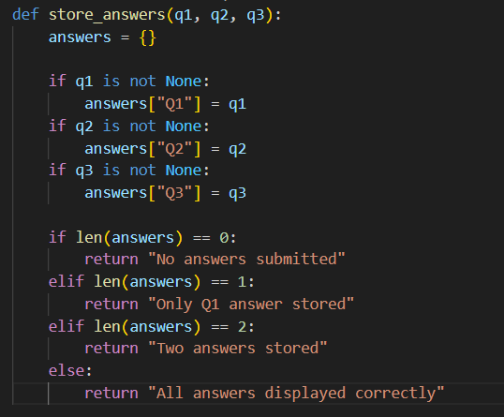

The Output is matched to all the above test cases mentioned in table, then Black Box testing is successful.

7.Conclusion

The Software Requirements Specification (SRS) for the Online Examination System defines the overall requirements, functionalities, and constraints needed to develop an efficient and reliable examination platform. The system is designed to automate the process of conducting exams, managing questions, evaluating answers and generating results in a secure and organized manner. By providing modules for user authentication, examination management and evaluation, the system aims to reduce manual effort, improve accuracy and ensure fairness in the examination process. This document serves as a reference for developers, testers and stakeholders to understand the system requirements and to ensure that the final product meets the intended objectives of providing a smooth, transparent and scalable online examination environment.

8.References

- iitms.co.in, Online Examination System Features and Implementation.
- IJRASET (International Journal for Research in Applied Science and Engineering Technology), Research papers related to Online Examination Systems.
- Mettl (Mercer | Mettl), Online Assessment and Examination Platform.

9. Acknowledgement

I would like to express my sincere gratitude to my institution and faculty members for providing the opportunity to work on the Online Examination System project and for their valuable guidance throughout the preparation of this Software Requirements Specification (SRS) document.
I would also like to thank my classmates and friends for their support and suggestions during the development of this project. Finally, I acknowledge the online resources and reference materials such as IITMS, IJRASET, and Mettl which helped me understand the concepts of online examination systems.

Design Phase

Component Diagram:
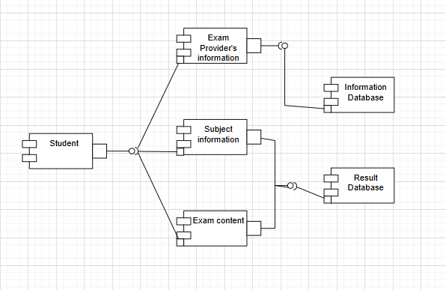

Description:
The component diagram represents the major software components of the Online Examination System and the interactions between them. It shows how the Student interacts with different modules such as Subject Information, Exam Content and Exam Provider’s Information to access examination services. The system stores and retrieves data using the Information Database and Result Database. This architecture separates the system into independent modules, making the system easier to manage, maintain and update.

Deployment Diagram
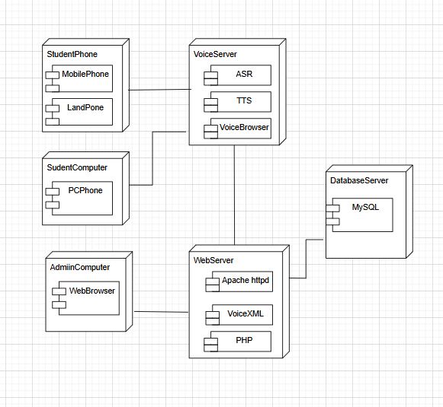

Description:
The deployment diagram illustrates the physical architecture of the system, including both hardware and software components. It shows how devices such as Student Phones, Student Computers and Admin Computers connect to the Voice Server, Web Server and Database Server. The servers host software components like ASR, TTS, Voice Browser, Apache HTTP Server, PHP and MySQL, which process user requests and manage system data. This architecture ensures efficient communication between users and the online examination system.

Product Matrix
For
Requirement Model

Product Matrix For Online Examination System:
i)Unadjusted Function Point:
Component | Count | Chosen Complexity | Weight | Total
External Input | 4 | Average | 4 | 16
External Output | 3 | Average | 5 | 15
External Inquiries | 3 | Average | 4 | 12
Internal Logical Files | 3 | Average | 10 | 30
External Interface Files | 1 | Low | 5 | 5
Count Total |  |  |  | UFP=78

ii)Complexity Adjustment Factor:
They consider 14 general system characteristics.
Each factor is rated 0 to 5.

S.No | The Value Adjustment Factors | Rating
1 | Does the system require reliable backup and recovery? | 2
2 | Are specialized data communications required to transfer information to or from the application? | 1
3 | Are there distributed processing functions? | 1
4 | Is performance critical? | 2
5 | Will the system run in an existing, heavily utilized operational environment? | 1
6 | Does the system require online data entry? | 5
7 | Does the online data entry require the input transaction to be built over multiple screens or operations? | 2
8 | Are the ILFs updated online? | 4
9 | Are the inputs, outputs, files, or inquiries complex? | 2
10 | Is the internal processing complex? | 2
11 | Is the code designed to be reusable? | 2
12 | Are conversion and installation included in the design? | 1
13 | Is the system designed for multiple installations in different organizations? | 1
14 | Is the application designed to facilitate change and ease of use by the user? | 3
Total Count |  | ΣFi=29

CAF=0.65+0.01x ΣFi
CAF=0.65+0.01x29
CAF=0.94
Function Point:
FP=Count Total x [0.65+0.01x ΣFi]
FP=UFPxCAF
Count Total or UFP=78
CAF=0.94
FP=78x0.94
FP=73
The Function Point of this online Examination System is 73.
Function Point Based Effort and Cost Estimation:

1. Estimated Development Effort:
Assuming that 1 Function Point ≈ 10 development hours:
$$\text{Development Effort}=73×10=730\text{ hours}$$
Therefore, the estimated development effort required for the Online Examination System is 730 hours.

2. Estimated Development Time:
Assuming that 1 developer works 8 hours per day:
$$\text{Development Time}=\frac{730}{8}=91.25\text{ days}$$
Therefore, the estimated development time is approximately 91 days.

3. Estimated Development Cost:
Assuming the developer cost is ₹1000 per hour:
$$\text{Development Cost}=730×1000=\text{₹}7,30,000$$
Therefore, the estimated development cost of the Online Examination System is ₹7,30,000.

Empirical Estimation Models(COCOMO Model)

The estimated size of the project is 10 KLOC, which represents approximately 10,000 lines of source code. This project comes under organic mode.
This estimation is considered for calculating the effortdevelopmenttime, and staffing requirements of the software project using the COCOMO model.

i)Basic COCOMO Model:

The Basic COCOMO can be used for quick and slightly rough calculations of Software Costs.
The following formulas are used to calculate effort and time estimates.

Effort ( E ) = A*(KLOC)^B
Time (T) = C*(Effort)^D
Persons required = Effort / Time
Estimated Size = 10 KLOC

The constant values A, B, C and D for the Basic Model for the different categories of software projects.
Since the proposed software project is classified under the Organic mode, the standard Basic COCOMO model coefficients are taken as A = 2.4, B = 1.05, C = 2.5, and D = 0.38.

a)Calculating Effort:
Effort = A*(KLOC)^B
Effort=2.4(10)^1.05
Effort=2.4x11.22
Effort=26.93 person-months

b)Calculating Time:
Time=C*(Effort)^D
Time=2.5x(26.93)^0.38
Time=8.75 months

c)Calculating Persons Required:
Persons required = Effort / Time
Persons required=26.93/8.75
Persons required=3 persons

Thus, according to the Basic COCOMO Model:
- Estimated Effort = 26.93 Person-Months
- Estimated Development Time = 8.75 Months
- Average Team Size = 3 Persons

ii)Intermediate COCOMO Model:

In the intermediate COCOMO model, various other factors such as reliability, experience, and
Capability are considered along with LOC to estimate effort and time schedule.
These factors are known as Cost Drivers and the Intermediate Model utilizes 15 such drivers forcost estimation.

Effort= A × (KLOC)^B × EAF
Time =C× (Effort)^D
Persons required = Effort / Time

The constant values A, B, C and D for the Basic Model for the different categories of software projects.
Since the proposed software project is classified under the Organic mode, the standard Basic COCOMO model coefficients are taken as A = 3.2, B = 1.05, C = 2.5, and D = 0.38.

a)Calculating EAF:

S.No | Cost Driver Factors | Rating | Multiplier
1 | Required software reliability extent | High | 1.15
2 | Size of the application database | Normal | 1.00
3 | The complexity of the product | High | 1.15
4 | Run-time performance constraints | Normal | 1.00
5 | Memory constraints | Nominal | 1.00
6 | The volatility of the virtual machine environment | Nominal | 1.00
7 | Required turnabout time | Nominal | 1.00
8 | Analyst capability | High | 0.86
9 | Software engineering capability | Nominal | 1.00
10 | Applications experience | Nominal | 1.00
11 | Virtual machine experience | Nominal | 1.00
12 | Programming language experience | Nominal | 1.00
13 | Use of software tools | High | 0.91
14 | Application of software engineering methods | High | 0.91
15 | Required development schedule | Nominal | 1.00

EAF=1.15×1.00×1.15×1.00×1.00×1.00×1.00×0.86×1.00×1.00×1.00×1.00x0.91x0.91x1.00
EAF=1.03

b)Calculating Effort:
Effort = A × (KLOC)^B × EAF
Effort=3.2(10)^1.05x1.03
Effort=3.2x11.22x1.03
Effort=36.98 person-months

c)Calculating Time:
Time=C*(Effort)^D
Time=2.5x(36.98)^0.38
Time=9.86 months

d)Calculating Persons Required:
Persons required = Effort / Time
Persons required=36.98/9.86
Persons required=3.75 persons(Approx 4 persons)

Thus, according to the Intermediate COCOMO Model:
- Estimated Effort = 36.98 Person-Months
- Estimated Development Time = 9.86 Months
- Average Team Size = 4 Persons

